Serverless Development 101

**HOP10 – Build an app with REST API - DELETE**

5/17/2020 Created by Apiwat Chuaphan

Center for Information Assurance (CIAE) @City University of Seattle (CityU)

  

**Learning Outcomes**

* Learn what REST API is and how it works
* Learn basic CRUD
* Learn how items store in DynamoDB
* Build an app with AWS Lambda, API Gateway, DynamoDB, REST API

**Build the D from CRUD paradigm.**

1. Open the VSCode and open the “**myproject**” project folder that we developed a web application using serverless computing in the previous module.
2. Go to **todos** folder and get inside **functions** folder.
3. Create a new file named **delete.js** to read all of our data in the database. Then update the file with the content [here](https://bit.ly/2zmcA8v)

**delete(params, callback)**

* Deletes a single item in a table by primary key by delegating to AWS.DynamoDB.deleteItem()

1. After we added new function, we need to let Lambda know our new function by updating **serverless.yml** as follow

1. Run sls deploy -v to deploy our function to Lambda. This time we have to deploy the entire process because we updated **serverless.yml** (*Make sure you’re in the* ***“todos” f****older)*
2. Head to AWS Lambda page and hit refresh to see that our new function has been deployed.

1. Verify if the function does what we expect it to do. Run this command in the terminal

>>> **curl -X DELETE <your-api-url>/id**

Replace **<your-api-url>** with your endpoint and replace **id** with your item id of which you want to delete.

We should see the output which returns the empty in the JSON object, **{}** back in terminal.

1. Verify if the delete function really delete the item we wanted to. Run this command in terminal

>>> **curl <your-api-url>**

This will return the empty JSON since the delete function did its job perfectly.

1. Go to DynamoDB to see if the item has been deleted.

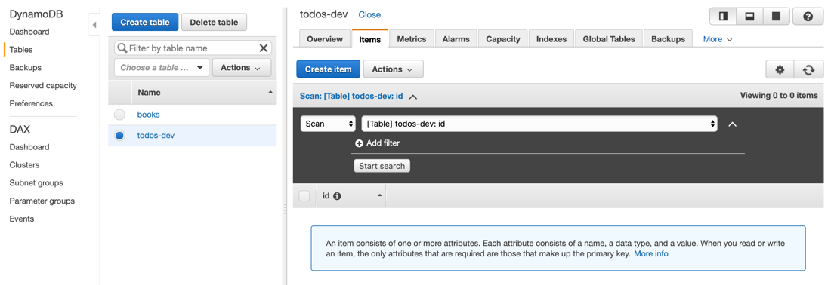

**CONGRATS**! 🎉👏

You’ve just created the REST API app using Serverless technology on AWS. Now is your time to apply this to be nicer for users to use your app with frontend of your choice.

**Push your work to GitHub**

Open the terminal from the VSCode by hit the control + ~ key and type the following command:

Run the following commands to push your work to the GitHub repository:

>>> git add .

>>> git commit -m “Submission for Module 10”

>>> git push origin YOUR_BRANCH_NAME

**Note**: you should change the YOUR_BRANCH_NAME to your own branch name. It should be firstname-lastname (e.g. maria-gracia).

If you cannot remember, run the command “git status” to check